**Assignment 1: (Spring 2021) Graded**

**PHYSICS (PHY101)**

**TOTAL MARKS: 25**

**Due Date: 26/07/2021**

**DON’T MISS THESE *Important instructions:***

* To solve this assignment, you should have good command over first 28 lectures.
* Upload assignments (Microsoft word) properly through LMS, (No Assignment will be accepted through email).
* Write your ID on the top of your solution file.
* All students are directed to use the font and style of text as is used in this document.
* Don’t use colorful back grounds in your solution files.
* Use Math Type or Equation Editor etc for mathematical symbols.
* Write to the point and avoid from unnecessary explanation. Don’t copy/paste from internet or any other source.
* This is not a group assignment, it is an individual assignment so be careful and avoid copying others’ work. If some assignment is found to be copy of some other, both will be awarded zero marks. It also suggests you to keep your assignment safe from others. No excuse will be accepted by anyone if found to be copying or letting others copy.

**Don’t wait for the last date to submit your assignment.**

**Question # 1**

The student of Physics claims that he has calculated a negative potential difference between two points. Is it true or wrong? Either yes or no explain it by giving a suitable example. Marks = 5

**Question # 2**

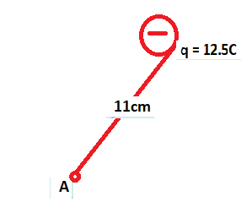

Determine the magnitude as well as direction of the electric field at point A, shown in the above figure. Given the value of k = 8.99 × 1012N/C. Marks = 10

**Question # 3**

In the figure shown, the lamp cord is 85cm long and comprises cupper wire. Calculate the wire‘s resistance? Use value of resistivity for Cu as 1.75 × 10-8Ωm. Marks = 10

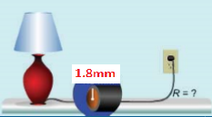

>>>>>>>>>>>>>>>>>Best of Luck for you<<<<<<<<<<<<<<<<<<<<<<<